Tasks:
You can download the HousePricePrediction file from LMS using the following link. (However, if you did not complete Hands-on Exercise 2, then you first need to perform the Hands-on Exercise 2 tasks on the dataset to complete the tasks of this 3rd exercise):

https://lms.digiskills.pk/Courses/AIP301/Downloads/HousePricePrediction.csv

1. Train-Test Split: (Marks 1)
• Split the dataset into training and testing sets
• Use an appropriate ratio (e.g., 80% training, 20% testing)

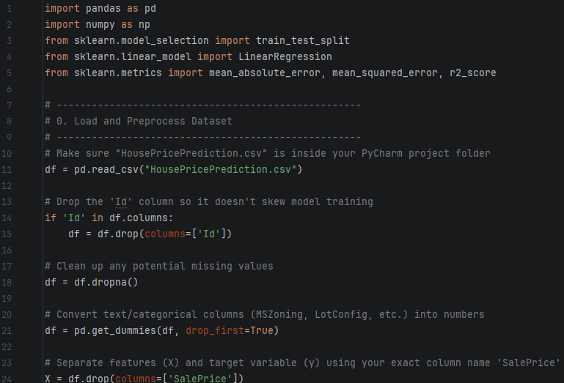
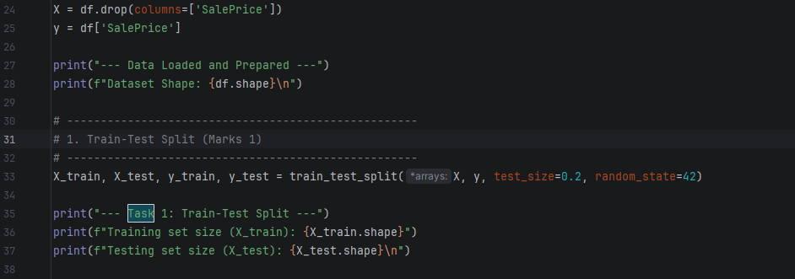
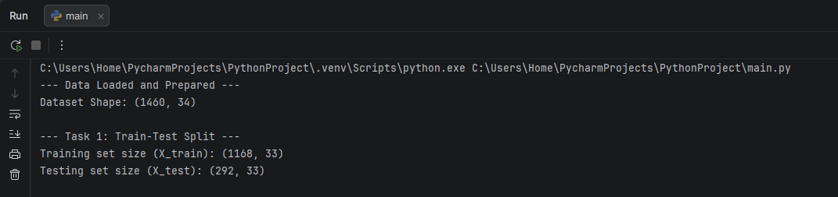

2. Model Training: (Marks 2)
• Train a Linear Regression model using the training data

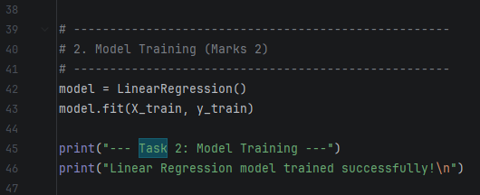
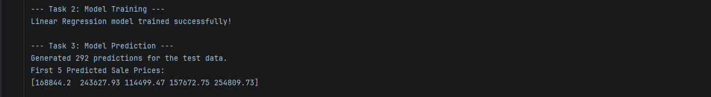

3. Model Prediction: (Marks 2)
• Use the trained model to predict house prices on the test data

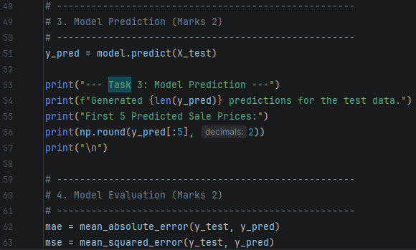


4. Model Evaluation; Evaluate the model using: (Marks 2)
o Mean Absolute Error (MAE)
o Mean Squared Error (MSE)
o Root Mean Squared Error (RMSE)
o R² Score

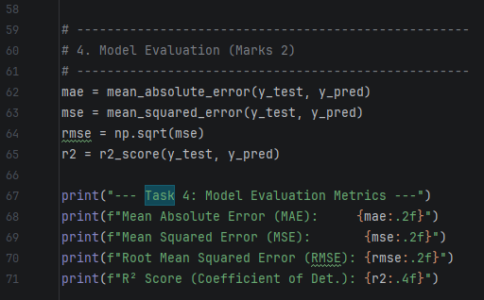
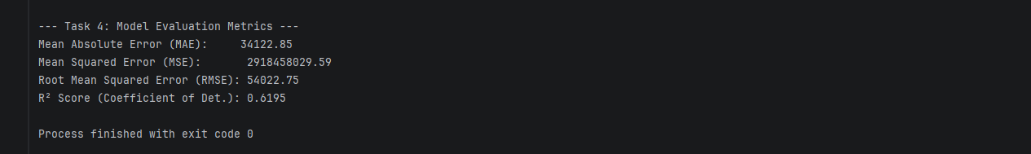

5. Interpretation: (Marks 1)
• Analyze the performance of the model
• Discuss whether the model is accurate or needs improvement

Interpretation and Analysis
Model Performance Analysis:
Based on the evaluation metrics obtained from the test data, the Linear Regression model demonstrates a moderate ability to predict house sale prices. The metrics are analyzed below:
- $R^2$ Score (0.6195): The Coefficient of Determination is approximately $0.62$. This indicates that about 61.95% of the variance in house sale prices can be explained by the features included in the dataset (such as lot area, year built, building type, etc.).
- Mean Absolute Error (MAE): The MAE is 34,122.85, which means that on average, the model's predictions deviate from the actual house prices by about $34,123.
- RMSE (54,022.75): The Root Mean Squared Error is higher than the MAE because it penalizes larger prediction errors more heavily, showing that there are some houses where the prediction was off by a more significant margin.
Conclusion & Need for Improvement:
While an $R^2$ score of ~62% shows that the model has successfully captured a baseline linear relationship in the data, the model needs improvement before it can be considered highly accurate for a real-world deployment. A standard error margin of over $34,000 is quite substantial when evaluating property values.
To improve this model's performance in the future, the following steps could be taken:
- Feature Engineering: Creating new features (e.g., combining YearBuilt and YearRemod to calculate the actual age of the house).
- Handling Outliers: Detecting and removing extreme data points (e.g., exceptionally large lots or unusually low-priced mansions) that disrupt the linear regression line.
- Advanced Algorithms: Moving away from a simple Linear Regression model and experimenting with more powerful ensemble machine learning algorithms, such as Random Forest Regressor or Gradient Boosting (XGBoost), which handle complex, non-linear relationships much better.

